Earth Day 10K Map Washington Crossing Park, NJ side
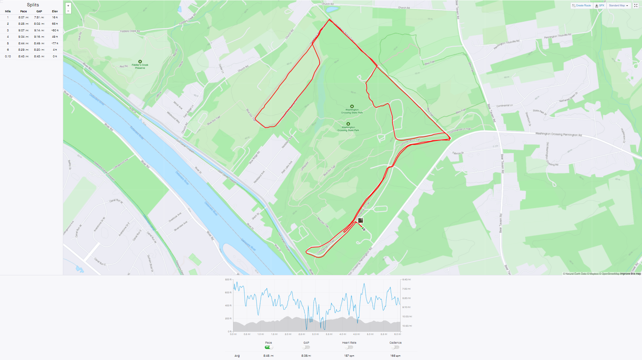
The Earth Day course is 80% paved park road with the horse trail loop on the far side at about mile 2.5. There will be aid at mile 2 and mile 4. The course finishes on the historic Continental Trail. The start & finish is in front of the visitor center.
Beast Mode 5K course
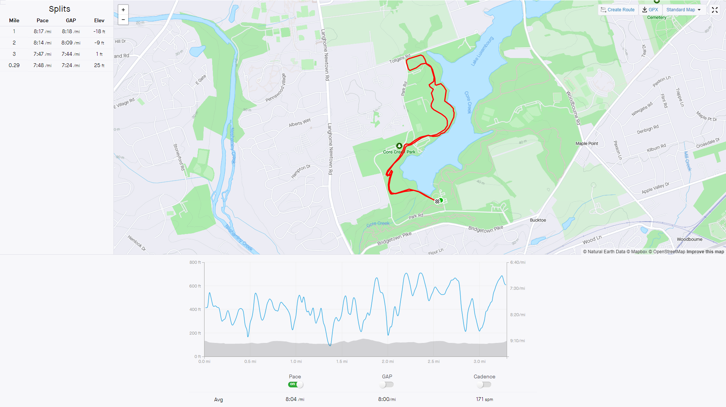
The Beast Mode 5K course starts on pavement then quickly turns to field running to get back on paved park path. You stay on the path for about a half mile till you take the gorgeous lakeside trail up to the dog park. Around the dog park you go on grass and head back to the paved path after a short single track trail section. You then cross the same field you started on to the finish. This is a fun mixed course that will challenge your PR.
BCTC Time Trial
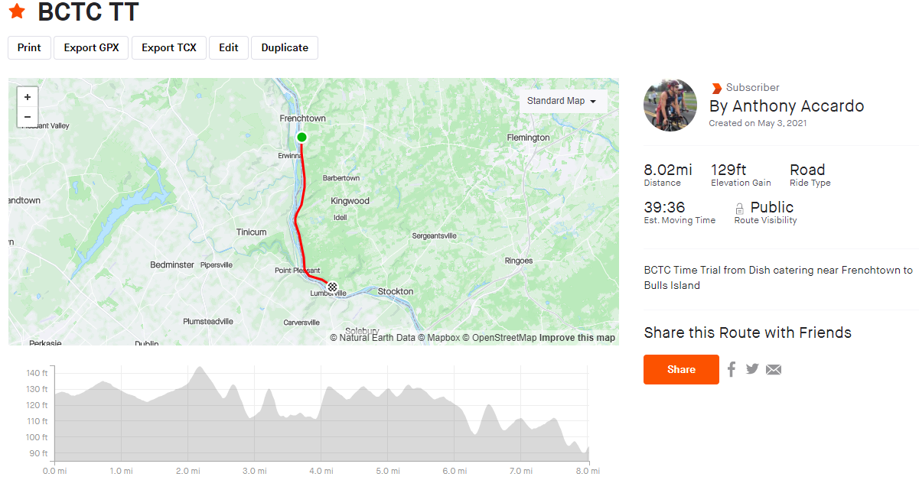
An 8 mile straight shot from Frenchtown to Bulls Island on the wide rolling shoulder of Rt. 29.
Solstice River Swim
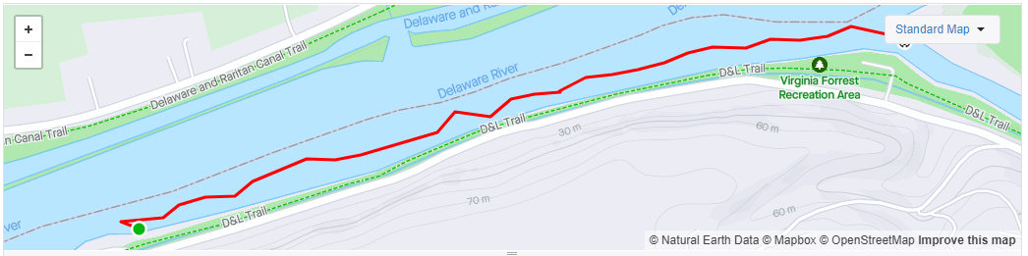
1 mile swim with the current unless conditions allow us to swim up and back. Starting / Ending at Virginia Forrest.

Mountain Bike Tournament Course
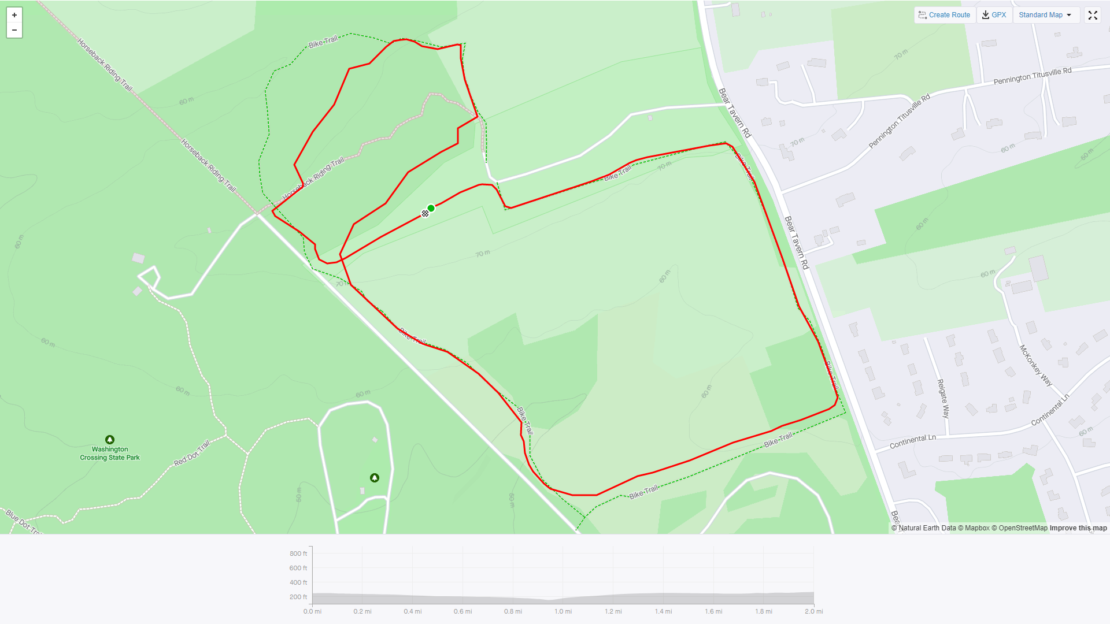
This is a fast 2 mile course in Washington Crossing Park with about 120 feet of climbing. There are a few technical sections but is mostly fields and horse trails.
DRR Duathlon
Maps will be posted soon. The Sprint course starts with a 3 mile out & back run on the canal path from Bulls Island heading North. The Sprint bike will be 15 rolling miles along Rt 29. For the Half we will race the same course we did in 2021. The first run will be 3 miles on the canal path. The 51 mile 2 loop bike course really shows off the beauty of the Delaware river valley featuring a challenging climb up Federal Twist.
The rest of the course rolls along Rt 29. We thought you might need a break from the hill so we kept the 2nd 10 mile run on the canal path where you will have aid at the 5 mile turn-around.

