Thank you  Thank you for supporting the Bucks County Triathlon Club (BCTC) and the Autism Cares Foundation. Proceeds from tonight’s event will support the expenses & development of BCTC & ACF  Autism Cares Foundation (ACF) is a non-profit 501© (3) charity that was founded by the parents of a child with autism and other concerned parents, professionals and friends. The foundation was started as a means of helping people through the “puzzle” that is autism. At virtually every level, there are “twists and turns” in one’s attempt to reach the answers that many parents are seeking. As the founders discovered with their own child, answers are few, frustrations are many, and there are few places to turn to for answers.  In an effort to bridge the gaps, Autism Cares Foundation provides informational resources and up to 150 life enrichment activities and programs for children, teens and adults with autism. Our life enrichment programs span a range from social outings, skills development, iPad learning sessions, Glee Club, weekly fitness, annual Halloween and Holiday Parties and more!  Autism Cares Foundation  P.O. Box 180  Richboro, PA 18954  (215) 559-CARE (2273)  www.AutismCaresFoundation.org  www.buckscotriclub.com  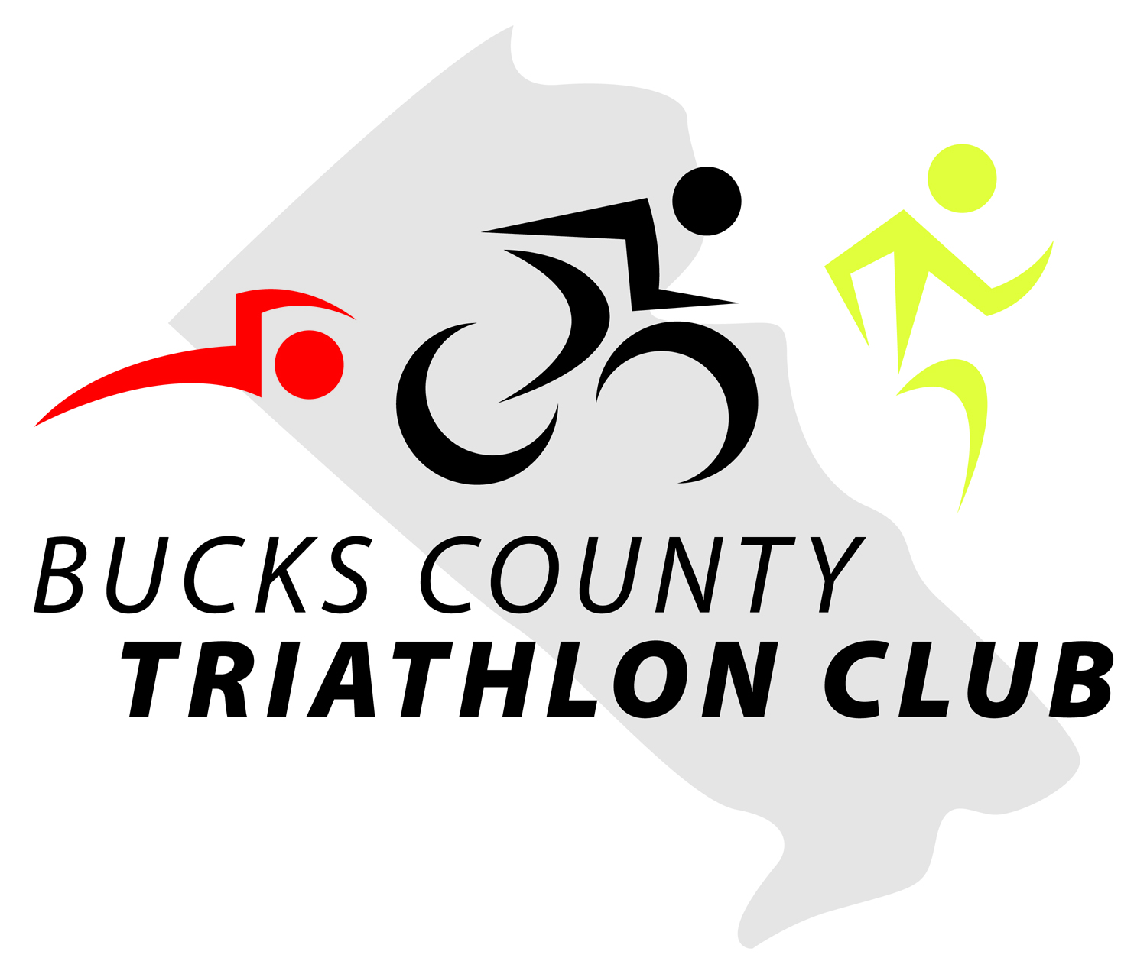 |  |  | Charity  Wine & Dine  To benefit The Autism Cares Foundation & BCTC  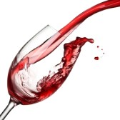

Auction Items  Silent Auction Items  Montes Purple Angel 2012 92pts. opening bid $50  Faust The Pact 2012 95pts opening bid $125  Franciscan Cabernet 2011 1.5L Napa opening bid $50  Rodney Strong Reserve Cabernet 1.5L 2011 opening bid $85  J. Lohr Cabernet 1.5L 2012 Paso Robles opening bid $40 - 4 Dom Perignon Luminous 2004 opening bid $250  Ferrari Carano Cabernet 3L 2012 91pts opening bid $250  Rodney Strong Symmetry 2012 opening bid $65  Lock Stock & Barrel 13yr Rye 101.3 proof opening bid $100  JD Sinatra Century Limited Edition 100 proof opening bid $500  Raffle Items: Door prizes will be drawn from Raffle Tickets  27 Tickets $20 Raffles will be drawn at 10pm  12 Tickets $10  3 tickets per item  Patriots Crossing $25 G.C.  Bodega Norton Malbec 1.5L 2014  BCTC Hoodie Lg or XL  BCTC Long Sleeve Tech  Back Pack  Golf Bag  ACF Jacket  Race for Resources entries  Basket of minis- assortment of 50ml liquors  Italian Wine Basket  Featured Cocktails  Tanteo Jalepeno Margarita- Tanteo Jalepeno Tequila, fresh lime juice & a touch of agave nectar. Served on the rocks  - Absolut Kahlua White Russian- Absolut Pure Vodka, Kahlua Coffee Liqueur & cream  If your photo is not a flawless fit for the space, you can crop it to fit in almost no time. Just select the picture and then, on the Picture Tools Format tab, click Crop. |  |  | Table #1  - Guarachi Wine Partners & Cameron Hughes  Bodega Norton Malbec Reserve, Argentina  Bodega Norton Privada, Argentina  Montes Alpha Pinot Noir, Chile  Santa Ema Reserve Merlot, Chile  Black Ink Red, California  Montes Alpha Chardonnay, Chile  Cameron Hughes  Cam Collection Chardonnay, Monterey  Cam Collection Pinot Noir, California  Zin Your Face, California  Table #2  - Vintage Wines  PromisQous White, California  PromisQous Red, California  - Deep Purple Zinfandel, Lodi  Purple Cowboy Red, Paso Robles  Purple Cowboy Cabernet, Paso Robles  Monogamy Cabernet, North Coast  Middle Sister Wicked White, California

Table #3  Treasury Wine Estates & Freixenet  Beringer Luminous Chardonnay, Napa  Beringer Sauvignon Blanc, Napa  Chateau St. Jean Pinot Noir, California  Stags’ Leap Petite Sirah, Napa  Pepperjack Shiraz Blend, Barossa  Gloria Ferrer Blanc de Noir, Carneros  Gloria Ferrer Pinot Noir, Carneros  Segura Viudas Reserva Heredad, Spain  Table #4  - Rodney Strong & Kobrand  Rodney Strong Charlottes Home Sauvignon Blanc, Sonoma  Rodney Strong Chardonnay Sonoma  Rodney Strong Russian River Pinot Noir, Sonoma  Rodney Strong Merlot, Sonoma  Rodney Strong Alexander Valley Cabernet Sauvignon, Sonoma  Taittinger La Francaise  St. Francis Chardonnay, Sonoma  Jadot Pinot Noir, Burgundy  Tenuta Sette Ponti, Crognolo, Tuscany  Masi, Campofiorin, Veneto  Croft Reserve Tawny Port, Porto |  |  | Table #5  - Prestige Imports  Cliffhanger Pinot Grigio, Trentino  Cliffhanger Proprietor Red, Trentino  Mezzacorona Pinot Grigio, Trentino  Luigi Righetti SOL, Veneto  Castello di Querceto, Chianti Classico, Tuscany  Stemmari Pinot Noir, Sicily  - Stemmari Baci Vivaci, Sicily  Goosebump  Middleton Family Estates  - Buried Cane Chardonnay, Washington  Buried Cane Cabernet, Washington  Clayhouse Adobe White, California  Clayhouse Adobe Red, California  Table #6  - J. Lohr & Wagner Family  J. Lohr Estate Chardonnay, Paso Robles  J. Lohr Arroyo Vista Chardonnay, Paso Robles  J. Lohr Fume Crossing Sauvignon Blanc, Paso Robles  J. Lohr Los Osos Merlot, Paso Robles  J. Lohr Falcon Perch Pinot Noir, Paso Robles  J. Lohr Hilltop Cabernet Sauvignon, Paso Robles  Mer Soleil Silver Reserve Chardonnay, St. Lucia Highlands  Emmolo Sauvignon Blanc, Napa  Emmolo Merlot, Napa
Table #7  - Trinchero & Ferrari Carano  - Menage a Trois Moscato, California  Complicated Chardonnay, Sonoma  Menage a Trois Silk, California  Menage a Trois Midnight, California  Folie a Deux Chardonnay, Russian River  Napa Cellars Cabernet Sauvignon, Napa  Taken Red, Napa  Ferrari Carano Fume Blanc, Sonoma  Ferrari Carano Siena, Sonoma  Ferrari Carano Pinot Grigio, Sonoma  Ferrari Carano Cabernet Sauvignon (Auction Item)  Table #8  - Constellation & Huneeus  - Estancia Unoaked Chardonnay, Monterey  Franciscan Equilibrium, Napa  Clos du Bois Reserve Chardonnay, Sonoma  Estancia Pinot Noir, Monterey  Franciscan Cabernet Sauvignon, Napa (Auction Item)  Simi Cabernet Sauvignon, Alexander Valley  Ruffino Chianti Riserva Ducale, Tuscany  Faust, Cabernet Sauvigno, Napa  Saldo Zinfandel, California  Primus Red, Chile  Primus Malbec, Chile  Veramonte Red Blend, Chile |  |  | The Bar  Phillips Distilling, Featured Cocktails & Spirits  Macallan 15yr Fine Oak, Highland Single Malt  Macallan 12yr Sherry Cask, Highland Single Malt  Ardbeg 10yr Islay Single Malt  Bowmore 12yr Islay Single Malt  Johnnie Walker Select Casks 10yr Rye Cask Finish  Hochstadter’s Slow & Low Straight Rye, Orange & Honey  Hochstadter’s Lock, Stock & Barrel 13yr Rye (Auction Item)  Cavalry Bourbon Whiskey 90 proof Small Batch  Revel Stoke Pumpkin Spiced Whisky  Tomatin 12yr French Oak, Highland Single Malt  Tomatin 14yr Portwood, Highland Single Malt  Featured Cocktails  Apple Punch- Revel Stoke Roasted Apple, ginger ale & apple cider  Apple Pie (shot)- Revel Stoke Roasted Apple &  A splash of Bourbon cream  Cucumber Fizz- Prairie Cucumber Vodka, Lemonade &  A splash of club soda  - Thank you to R&R Marketing & all our Volunteers  from BCTC & ACF. After tonight’s event you can find  the great wines offered tonight at these great wine shops  Patriots Crossing in Titusville, NJ  Pine Creek Wine & Spirits in Ringoes, NJ  Little Brothers Wine & Spirits in Flemington, NJ  Super Saver in Pennington, NJ

Notes

